Individual players perfromance

Definition: Noise1 = Chance that a cooperation gets received as defection
Noise2 = Chance that a defection gets received as cooperation

The performance shows the average reward a player recieved, depending o the noise levels. The simulation was run twice, therefore each player has a second graphs.

In the cooperation dependant on the Noise tables values more to the right side mean higher Noise2 while lower rows mean higher Noise1.

Cooperate

Below is the cooperative player's performance in both simulations.

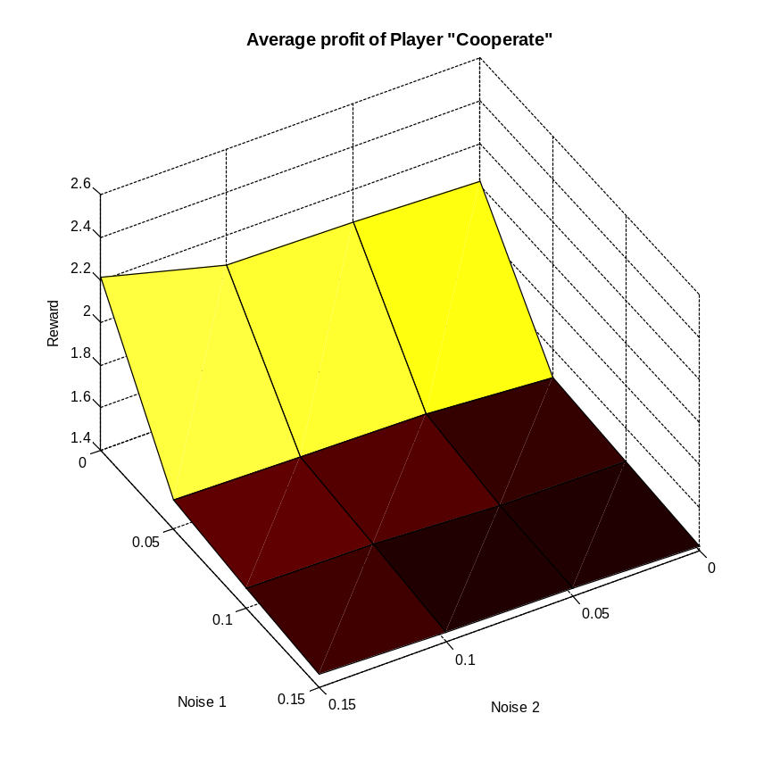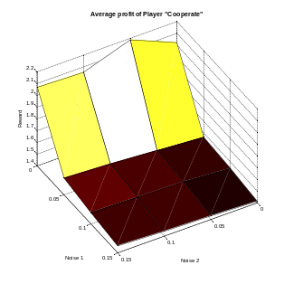
In a situation of no noise, this player performs strong against mostly friendly players, but gets exploited by aggressive players. In this situation it performs better than always defect, but similar to random.
Because this player is cooperative and not reactive Noise2 doesn't matter. On the other hand performance drastically decreases with Noise1. The seemingly inserted rejections make other players explore defective moves. Because the defective moves are not retaliated the other players might then stick with these defective moves. Players that start exploiting this player are Friedmann, Pavlov, CDowning and LookBack CDowning.
In a situation with noise this strategy is still strong with TFT mutants, because a cooperative interaction gets restored in the fastest possible way.
Still with a drop of 0.7 to 0.8 in performance this player is one of the players that is the most susceptible to noise overall.

Traits of the player:
+Can sustain cooperation with friendly players even in noise
-Exploitable
-Does not respond to the opponents move

Defect

Performance:
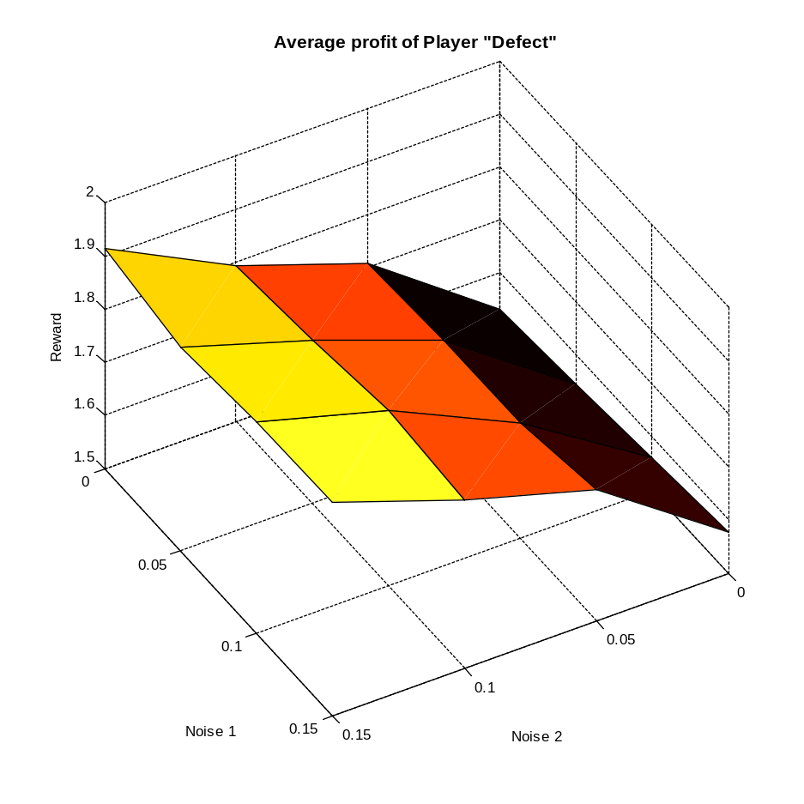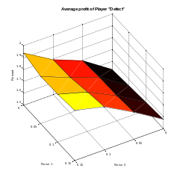
The player is so unfriendly, that Noise2 help him. A move where he can exploit the opponent gives him 5 times the reward of mutual defections, therefore even a small number of exploiting moves helps him a lot. If we would run the simulation with a Noise close to 50% this player would become the most successful player. The performance increases in general against TFT mutants, but especially against players that try hard to avoid mutual defections, such as TF2T, reconciliation TFT, limited Reconciliation TFT. The strongest rise in performance comes against the player Evolutionary.

Traits of the player:
+Can exploit players that do not respond
+performance increase with Noise
-Ends up in mutual defections with most players

Random

Below is the player's performance depending on the noise in both simulations.
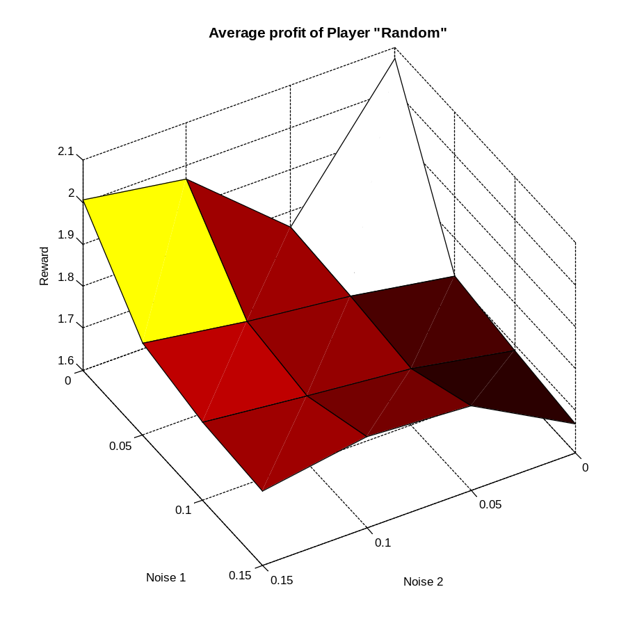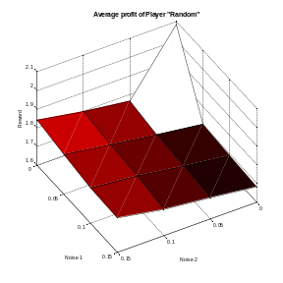
The player does not get influenced that much by noise. There is a strange peak at zero noise, we were unable to find out why. If the noise makes his moves appear a little more cooperate there is a slight increase in performance, most likely due to more cooperative reactions from TFT mutants.

Tit For Tat

Performance:
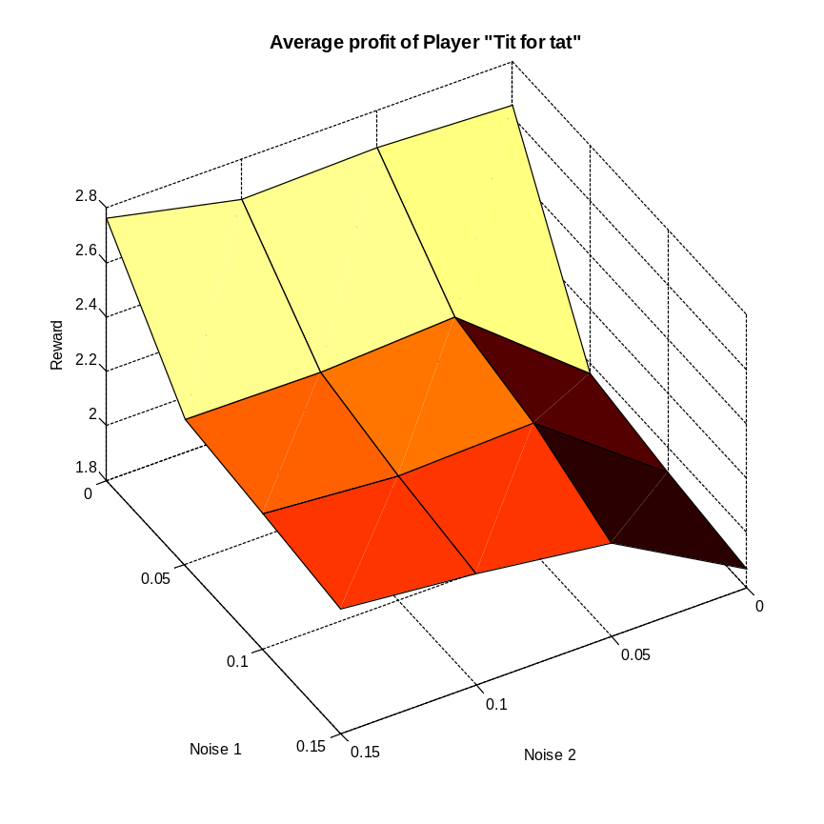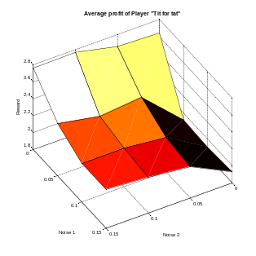
Tit for Tat (TFT) is a rather strong player. He won Axelrod's tournaments that were without noise. For Noise1=0 he is one of the strongest of all players. These graphs above show that this player is extremely susceptible to noise1. The reason is that with no noise 1 he will always cooperate with other TFT mutants because the first move was cooperative. With noise the first move maters less. There are basically three states he can enter with himself.
State 1: Mutual cooperation. Performance 3
State 2: Alternating defection and cooperation. Performance 2.5
State 3: Mutual defections. Performance 1
A Noise1 signal changes the state from state 1 to state 2 or state 2 to state 3. Noise2 works in the other direction. The two noises are basically transition probabilities. For Noise1 greater than zero and Noise2 equal to zero the TFT ends up stuck in state three with itself. For equal noises in both directions TFT should be 50% of the time in state 2 and 25% in the states 1 and 3. This would imply the performance: 0.25*3+0.5*2.5+0.25*1=2.25. The table below shows the performance of TFT against itself. Because the players in our simulation could only perform mirrored decisions state 2 was impossible and the actual performance was somewhat lower.

3.0000 3.0000 3.0000 3.0000
1.0016 2.0127 2.3438 2.4745
1.0018 1.6184 1.9847 2.1967
1.0011 1.5170 1.7666 2.0086

Cooperation of TFT depending on the Noise:
0.8075 0.8247 0.8351 0.8917
0.3958 0.5967 0.6192 0.6516
0.3418 0.5127 0.5428 0.5866
0.2886 0.4240 0.4836 0.5297

Already at Noise1=0.05 the number of cooperative moves TFT performs drops from 40 to 80 percent. At higher Noise2 with no Noise1 the number of defections performed by TFT halves.

Traits of the player:
+Responds fast
+Not exploitable
+Forgiving
-Only accepts an apology, but does not initiate it himself->stuck in mutual defections

Friedmann

Performance:

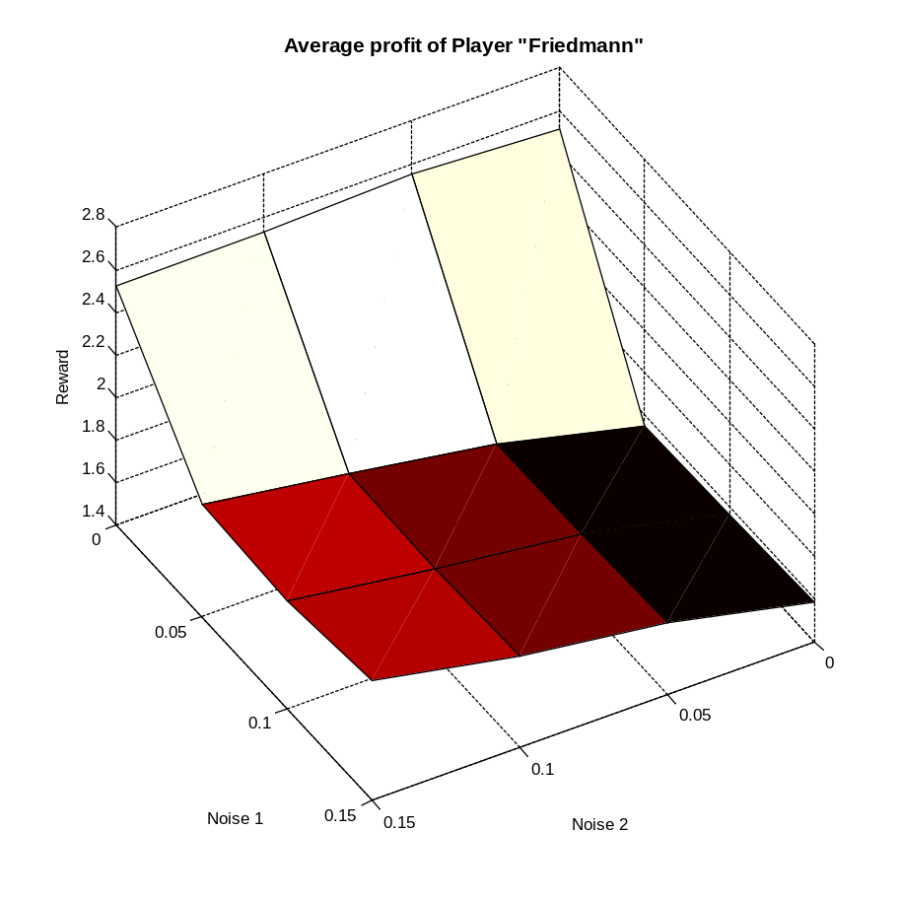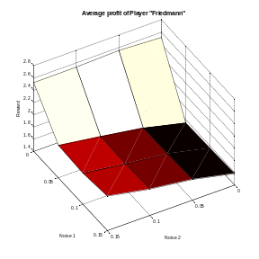

In the case of perfect information this player can profit from mutual cooperation with many players. In this case he performs well. However for any Noise1 greater than zero the player will receive a rejection at some point and therefore act like the player "Defect" most of the time. Friedmann generally tries to retaliate so hard on a rejection that the other player will not even attempt one rejection. However Friedmann cannot capitalise on this deterrent effect, because the moment the opponent realises it is already too late and he cannot know it in advance.
Cooperation of Friedmann dependant on the Noise
0.6002 0.6000 0.6000 0.6000
0.0004 0.0001 0.0001 0.0001
0.0001 0.0001 0.0001 0.0001
0.0001 0.0001 0.0001 0.0001

As soon as Noise1 is greater than 0 the number of cooperative moves goes to zero. But already at zero noise Friedmann only has 60% cooperative moves, while TFT has 80%.

Traits of the player:
+stays in mutual cooperation with friendly players when Noise1 is zero
-Completely breaks with Noise1 greater than zero

Pavlov

Performance:
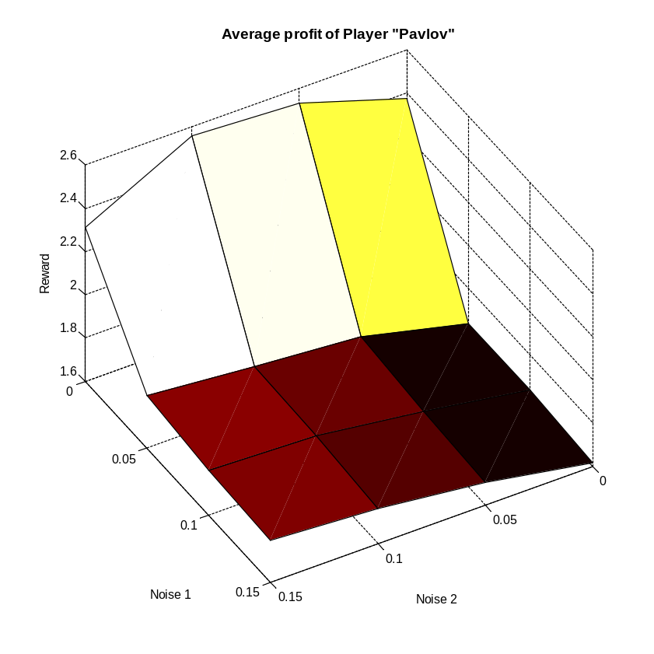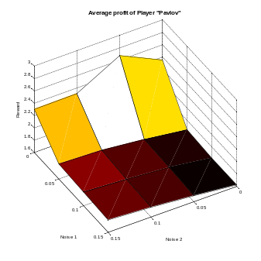
Pavlov performs rather well without Noise1. If Noise1 is greater then zero, some players realise that defections against Pavlov work as well as cooperations. Pure defect against Pavlov results in the rewards 5 1 5 1 5 1 for the opponent, while pure cooperation results in 3 3 3 3, given Pavlov is cooperative when the opponent started playing random. With zero noise the opponent gets an average reward of 3 for cooperation and defection but with noise the performance of cooperation decreases (because Pavlov retaliates). Players that largely start to defect against Pavlov are: Friedmann, Tit for average Tat, CDowning, LookBack CDowning and the Strategy switcher.

Cooperation of Pavlov depending on the Noise

0.8239 0.8488 0.8541 0.8037
0.4885 0.5433 0.5697 0.5860
0.4939 0.5211 0.5338 0.5455
0.5063 0.5187 0.5251 0.5319

Without Noise 1 the number of Cooperative moves is around 80% while it is around 50% with Noise 1. It is interessting that with Noise2 but no Noise1 Pavlov is less cooperative than TFT.

Traits of the player:
+Forgives fast
+Initializes cooperation out of mutual defection
+Not exploitable without noise
-Too many cooperative moves against defecting players
-Not retaliating (pure defect and pure cooperation perform equally well)

Tit for 2 Tat

Performance:

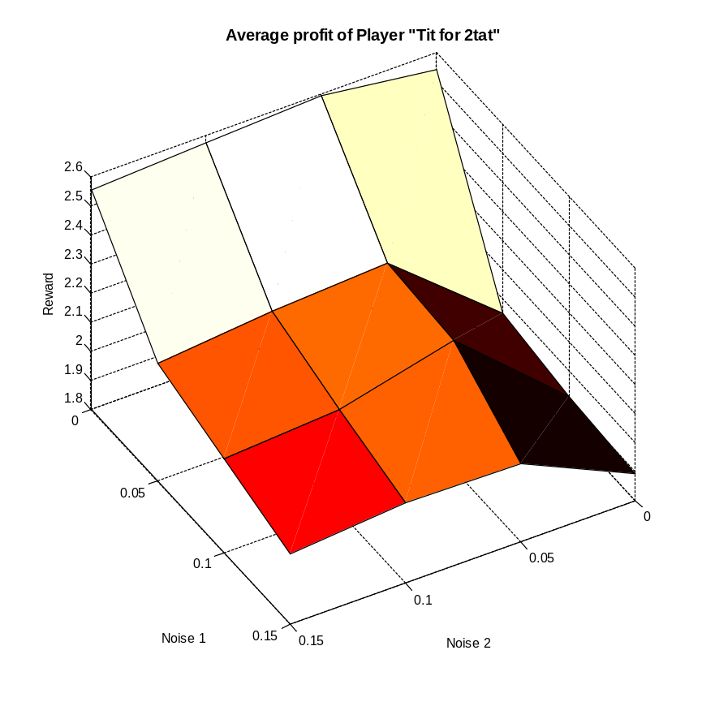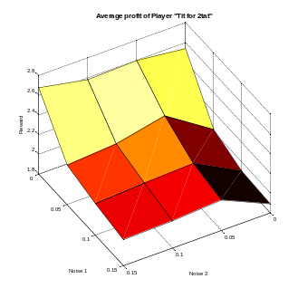

As a TFT mutant it has a similar performance. The difference is that this player is more forgiving. The bad thing is that this makes him exploitable. The better thing is that it is more robust to Noise1 as it does not react to single defections. The player still ends up in mutual defections with itself if Noise2 is zero and Noise1 greater than zero, but for both Noises greater than zero the player plays much stronger against itself. At zero noise the performance of TF2T is worse than the one of TFT, but with Noise1 their performances are similar. The effect that players like "Evolutionary" will exploit TF2T seems to balance out with the better resistance to noise.

Cooperation of TF2T depending on the Noise
0.8271 0.8796 0.8880 0.8947
0.5366 0.7450 0.7712 0.7926
0.5132 0.7349 0.7375 0.7622
0.4864 0.6503 0.6977 0.7274
The cooperation stays much higher than for TFT especially if Noise2 also isn't zero.

Traits different to TFT
+More Forgiving
-Exploitable

Joss

Performance:
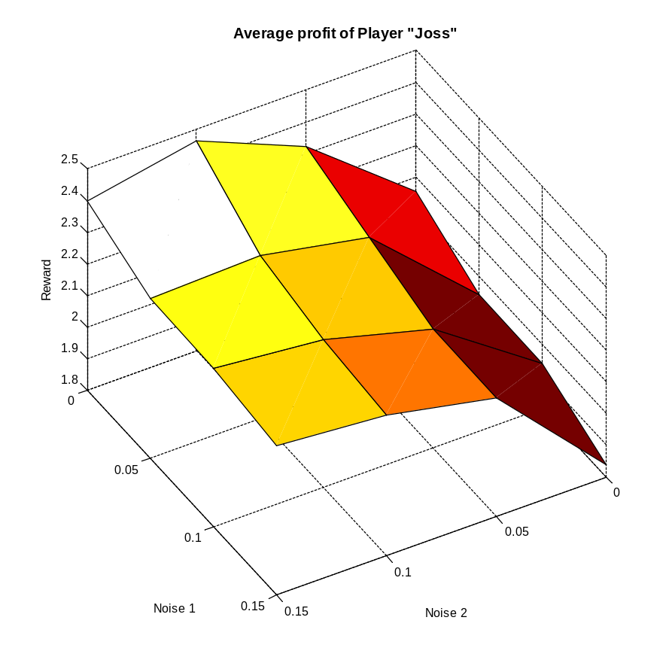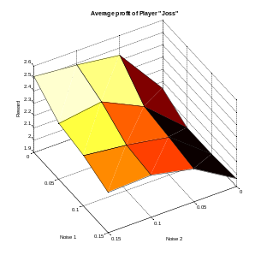
While this is a TFT mutant, its performance dependence on noise looks totally different. The player generally performs poorly. At some noises this player is able to exploit TF2T (Noise2 greater than 0 and Noise1 0) however most of the time the retaliation of the defections outweighs their gain. TFT is very susceptible to Noise1 and Joss makes himself look like under Noise1 to his opponent. It is interesting that the performance of this player looks like the performance of "Defect" just shifted about 0.5 upwards.

Cooperation of Joss depending on the Noise:
0.3983 0.5300 0.6102 0.6172
0.3246 0.4627 0.5161 0.5383
0.2968 0.4026 0.4625 0.5006
0.2404 0.3720 0.4225 0.4591

With higher Noise2 some cooperation can be achieved, but generally the player is mostly defecting.

Traits different to TFT
-initiates defections

Diekmann

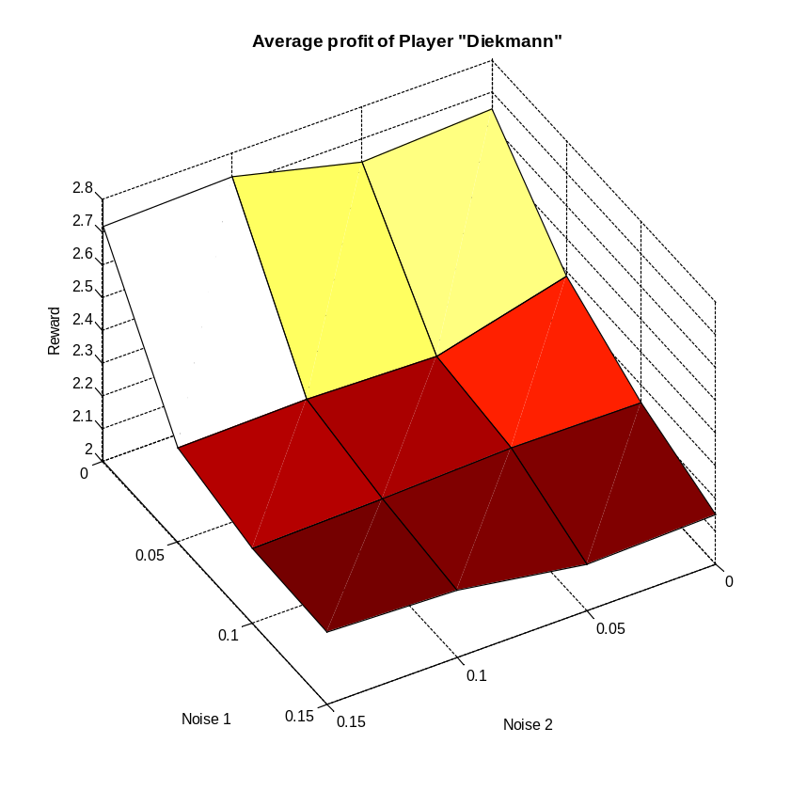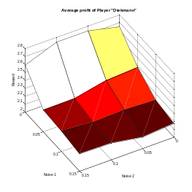

This is a TFT mutant, that performs on the same level as TFT at no noise, and is therefore one of the strongest players if there is no noise. While his performance also drops with Noise1 the effect is much less severe. For Noise1=0.05 and Noise2=0, TFT drops about 0.9, while Diekmann only drops 0.5. This player actually initiates cooperation and gets not stuck in mutual defection with TFT mutants. The weakness of this player is that he is exploitable by defective moves every 10 moves. However on our simulation we haven't seen a player exploiting this weakness. Evolutionary could exploit it if the period in which the algorithm updates would be a multiple of the period in which Diekmann inserts cooperative moves.

Cooperation of Diekmann depending on the noise:
0.8635 0.9034 0.9113 0.8741
0.7157 0.7263 0.7200 0.7359
0.6230 0.6500 0.6655 0.6946
0.5760 0.5895 0.6283 0.6496

The cooperation drops not nearly as much with the Noise as this is the case for TFT, he even is much more cooperative at no noise. At low noise2 values he is more cooperative than TF2T, but when both noises get high TF2T is more cooperative.
Traits different to TFT
+initiates cooperation
-exploitable

Tit for average Tat

Performance:
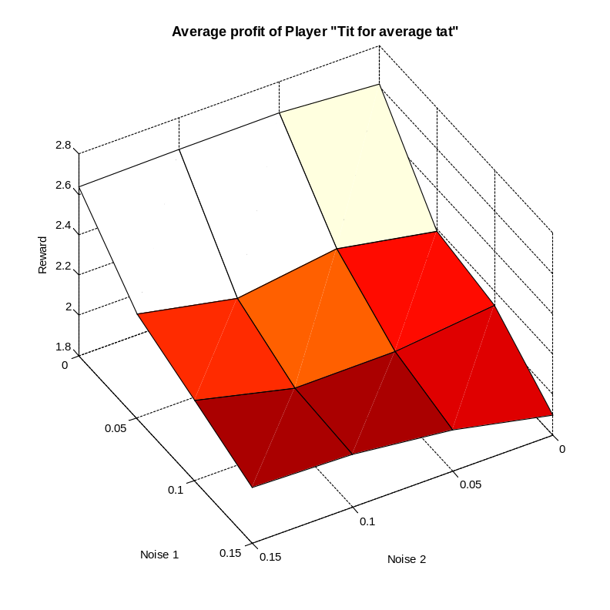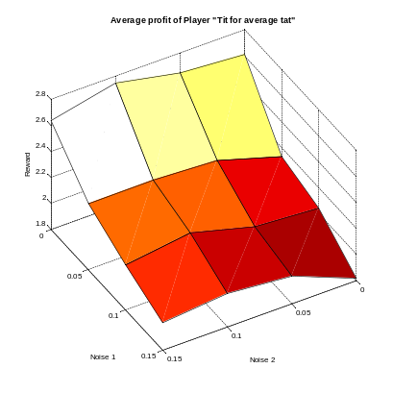
This TFT mutant looks very similar to Diekmann and other friendlier TFT mutants. The fact that it reacts to the players average move during the last turns allows him to ignore some of the noise. In generall this player performs about as well as Reconciliation TFT and a little bit worse than Diekmann. Theoretically this player is exploitable.

Cooperation of TFAT dependant on the noise
0.8056 0.8404 0.8456 0.8547
0.5316 0.6170 0.6140 0.6863
0.4712 0.4860 0.5100 0.5985
0.3419 0.4134 0.4660 0.5098

The cooperation drops surprisingly fast with Noise1, but still not as fast as for TFT. The number of cooperative moves is still more similar to TFT than Diekmann. This is surprising, that the performances look so close, while the underlying moves are so different. Diekmanns very nice approach seems to be just as efficient as TFAT's more retaliating method.

Traits different to TFT
+- ignores single moves
- exploitable
Reconciliation Tit for Tat

Performance:
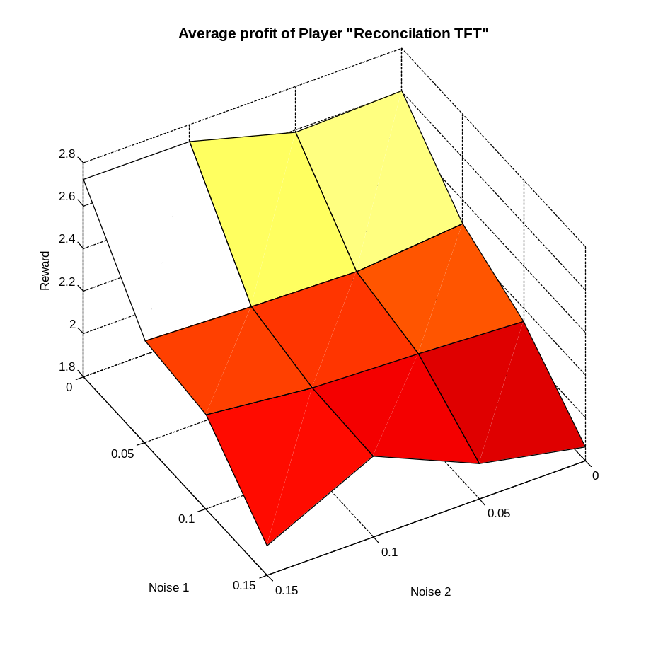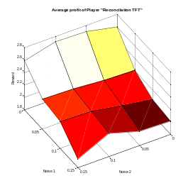
Like other more forgiving TFT mutants he has similar performance to TFT without noise, and drops less with noise1. The disadvantage of this player is that while it is not exploitable it still performs worse against defective players, when its reconciliation attempts are shut down over and over again.

Cooperation dependant on noise of RTFT
0.8728 0.8972 0.9033 0.8723
0.7169 0.7218 0.7397 0.7450
0.6861 0.7010 0.7175 0.7217
0.6930 0.6955 0.7161 0.6752

The number of cooperations is very high even with high noise1, at noise1=0.15 it's cooperation is higher than that of most TFT mutants. Generally the number of cooperative moves is more similar to Diekmann than to TFAT.

Traits different to TFT
+initiates cooperation
CDowning and DDowning

Performance CDowning:
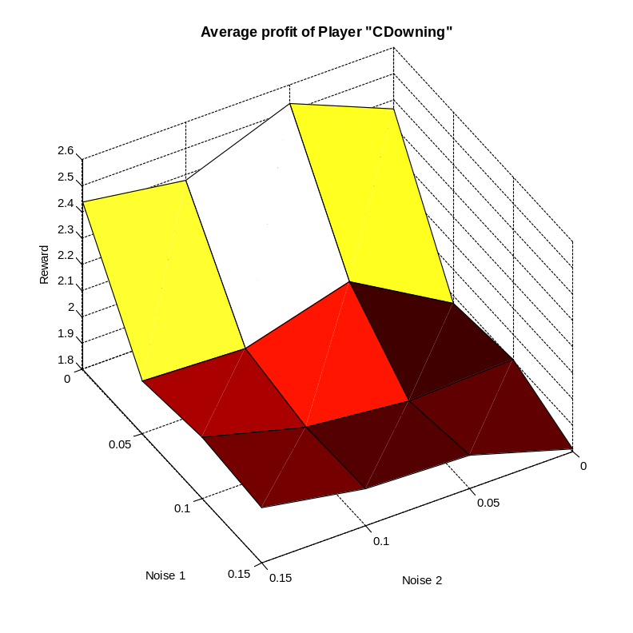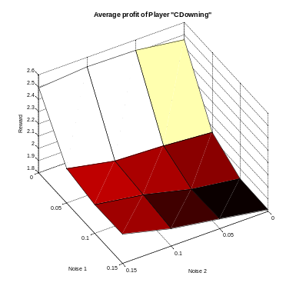
Performance DDowning
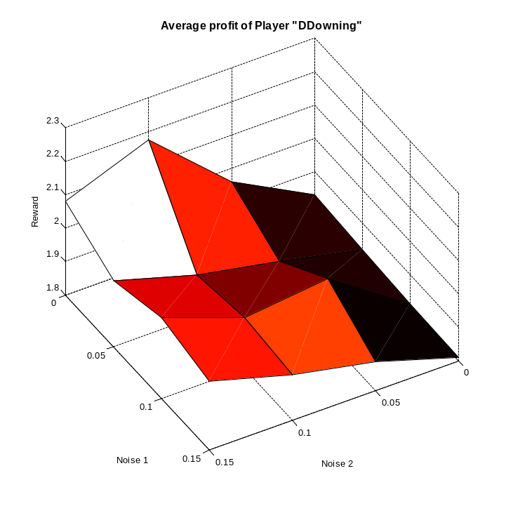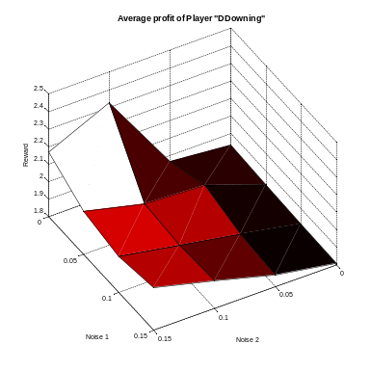
If Noise1 is zero, then CDownig performs stronger than DDowning. DDowning performs generally poorly with high Noise2 and no Noise1 there is a slight performance gain. At no noise DDowning outperforms CDowning against "Cooperate" and "Watcher", but is much worse against all TFT mutants and Friedmann. Noise2 improves the performance of DDowning against the TFT mutants a little. In the individual parings it seems that DDowning can end up in either mutual rejection or mutual cooperation. The decision where they end up seems to be random. For example at Noise2=0.15 mutual cooperation appears in TFT and TF2T, but not in Diekmann and Joss, while at Noise2=0.1 it is the other way around.

Cooperations of CDowning depending on the Noise:
0.7507 0.6013 0.7660 0.6504
0.1210 0.1711 0.0829 0.0507
0.1169 0.0507 0.0508 0.0508
0.0507 0.0745 0.0504 0.0505
Cooperations of DDowning depending on the Noise:
0.0500 0.1499 0.2997 0.3500
0.0500 0.0501 0.0517 0.0502
0.0500 0.1110 0.0503 0.0502
0.0501 0.0501 0.0501 0.0502

DDowning seems to reject almost all the time, while CDowning rejects most of the time if Noise1 is greater than 0. A problem of Downing is that it compares decisions that hapen at the same time, but at this time the opponent does not know Downings decision, so his decision can only be dependant on Downings past decisions.
TFT with reputation

Performance:

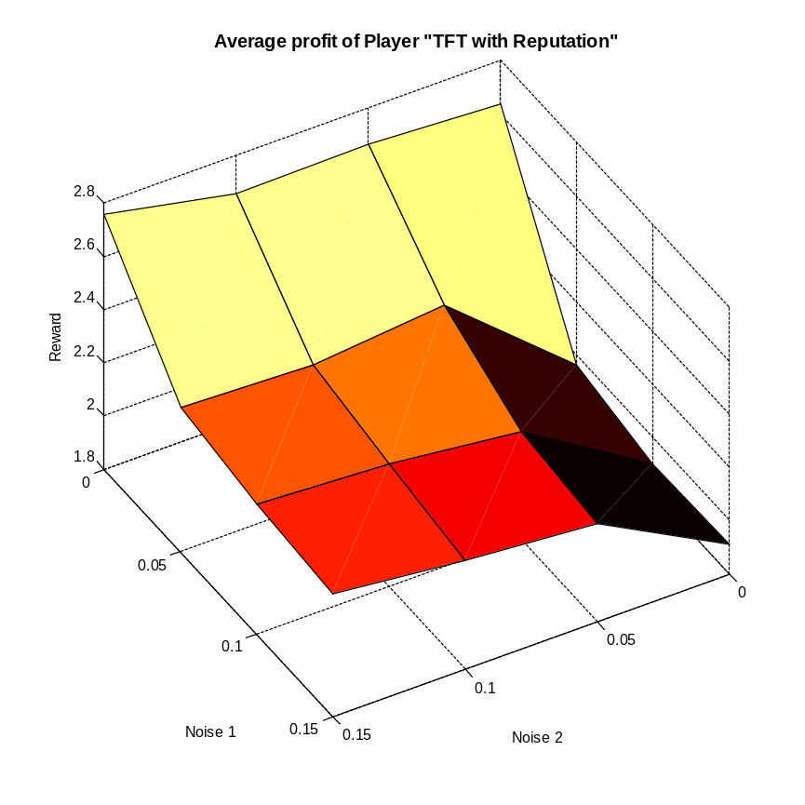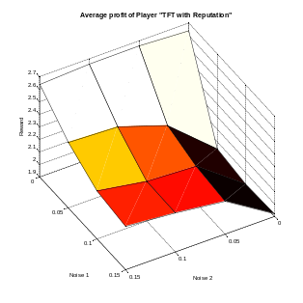
There were too many unfriendly players, that any player could have been friendly enough so that this player would have looked over a defection. The only player that would cooperate enough is "Cooperate". Against this player the number of cooperations was higher then the one of TFT, but because "Cooperate" is an exploitable player, this actually hurt this strategy.
In an environement where most players are cooperating this player could theoretically be exploited.

Cooperation of TFT with reputation dependant on the Noise:
0.8059 0.8218 0.8375 0.8440
0.3931 0.5722 0.6570 0.6933
0.3476 0.4939 0.5341 0.5942
0.3202 0.4402 0.4906 0.5349
This is very similar to TFT.

Traits of this player, different to TFT
-+no important differences
Strategy Switcher

Performance:

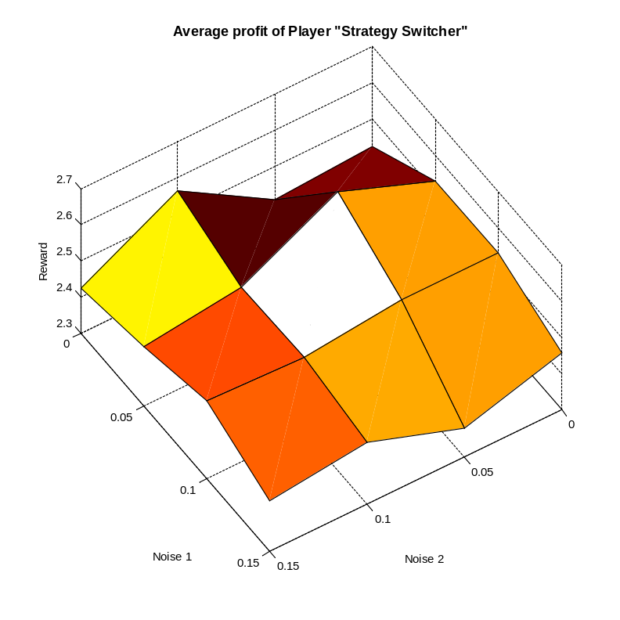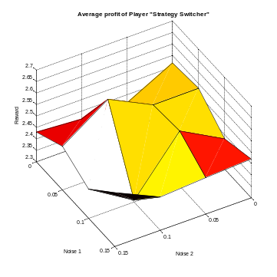
This player was by far the strongest player before the Downing players were added to the simulation. In the final simulation he is strong in fields, where the Noise is large as is performance is not impacted by noise. The disadvantage comes from trying out different strategies in the beginning. In the case of no noise this means that Friedmann will always defect. In the case of Downing mutants this seems to result in defections from the Downing players. Before these Downing players were added this player outperformed TFt by a huge margin, even at zero noise. The strength of this player comes from his ability to cooperate with TFT mutants and exploit exploitable players. This player might even be stronger if better strategies were given to his arsenal. Currently he had "Cooperate", "Defect", TFT, TF2T and Pavlov as choices. A more efficient choice might have been Limited Reconciliation TFT and "Defect". Currently it also contains exploitable strategies (TF2T), so the player could be exploited.
In long simulations the player can benefit from having the optimal strategy, while in short simulations he spends a large amount of the time trying out strategies that might not be very strong.

Cooperations of Strategy Switcher dependant on the Noise
0.5164 0.5430 0.4803 0.4659
0.5780 0.4701 0.5343 0.4844
0.5098 0.5520 0.4497 0.4888
0.5097 0.5318 0.4675 0.4467
The number of cooperations is rather low, but also does not change very much with the noise. The number of cooperations is most likely low, because this player actively looks if an opponent is exploitable.

Traits of this player
+Can exploit others
+Noise doesn't impact performance
+Very adaptive
+Strong in long simulations
-Exploitable himself
-Exploring defective moves can backfire (Friedmann)
-Is hard to read initially, this might trigger defections
-Weak in short simulations

LookBack CDowning and Lookback DDowning

Performance LookBacK CDowning:
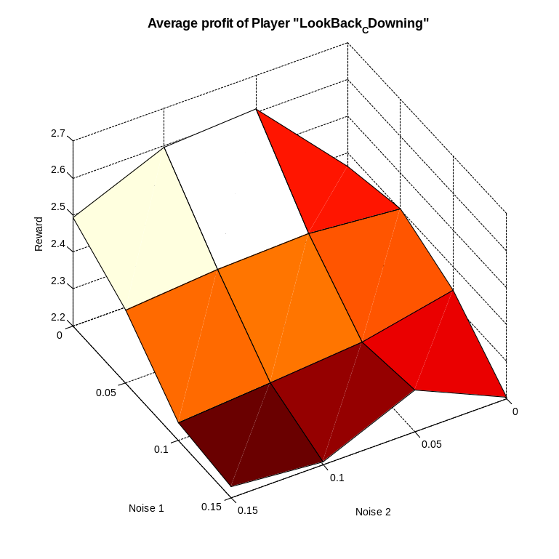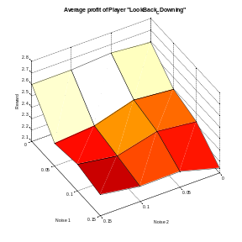
Performance Lookback DDowning
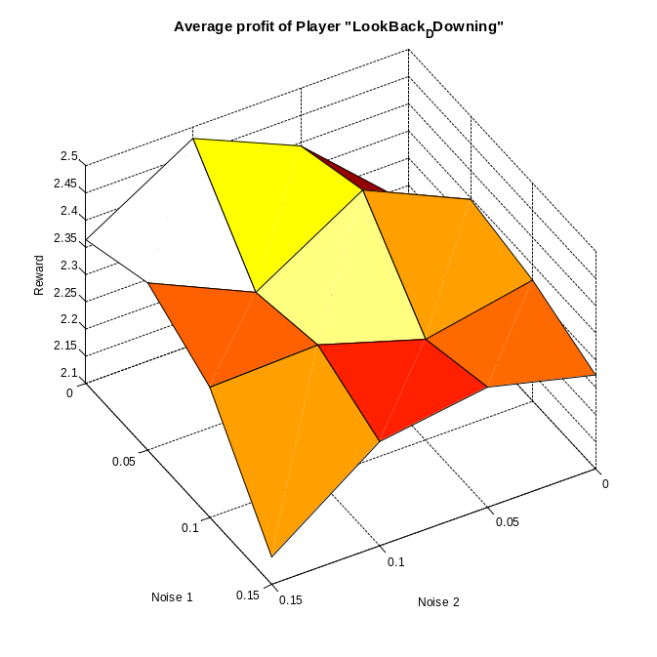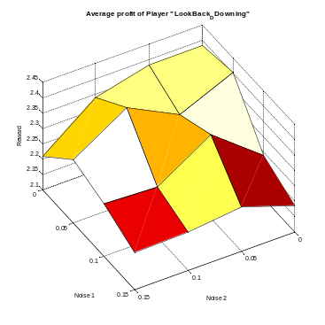
Generally both Lookback Downings are stronger than the not Lookback Downings. If Noise1 is zero, the CDowning mutant has again a higher performance. Comparing the second last move with the last move of the opponent seems to be the better way to correlate your actions with your opponent's actions. DDowning seems to be very resilent to Noise.
At zero noise CDowning performs well with most players, except "Evolutionary", Strategy Switcher, and some other Downing mutants. With noise the performance against Friedmann and some Downing mutants that went well before drops. The overall performance however stays higher than TFT. The Look-back Downing behaves similar like Lookback CDowning behaves with noise.

Number of Cooperations of Lookback CDowning Dependant on the Noise:
0.7507 0.6511 0.6509 0.7010
0.4385 0.4405 0.4376 0.4329
0.4297 0.3865 0.3787 0.3696
0.3814 0.4120 0.3682 0.3271

Number of Cooperations of Lookback DDowning Dependant on the Noise:

0.4037 0.4563 0.4071 0.4762
0.4386 0.3912 0.4303 0.3848
0.3864 0.4025 0.3784 0.3827
0.3868 0.3262 0.3840 0.3769

The number of Cooperations is in general much higher then for the Variants that do not look-back. For Noise1 greater than zero about 40% cooperative moves remain, while CDowning and DDowning fall down to 5-10% cooperative moves. The average rewards for these players are also 0.2-0.5 higher then their not look-back counterparts.

Watcher

Performance:
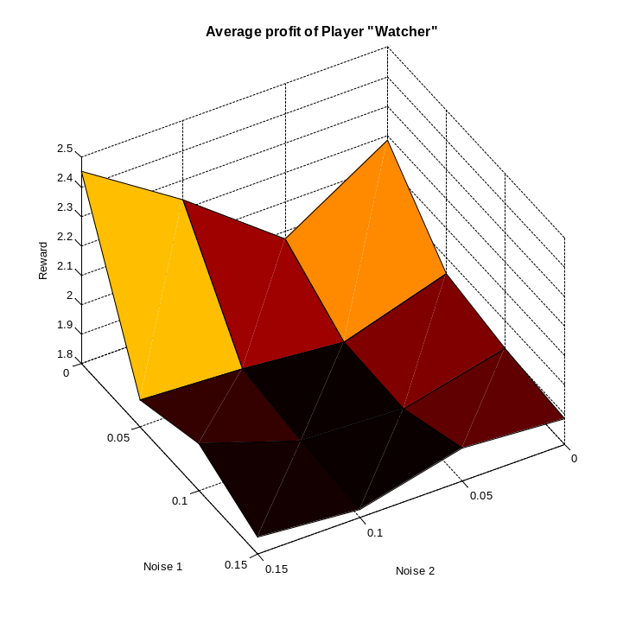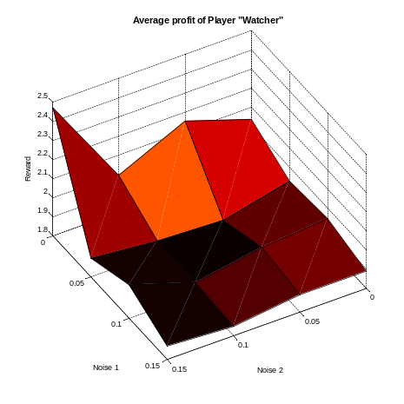
This player generally does not perform very strong. It does not respond and can therefore be exploited. It also does not take the local situation into account. It will betray Friedmann even in no Noise, because in short term this is successful. After that the player copies strategies that were cooperative the whole time, while Friedmann is defecting. There is point of higher performance, where Noise2 is 0.15 and Noise 1 is zero. For some reason it performs strong against the Lookback-Downing algorithms.

Cooperations against Noise:
0.5399 0.4704 0.4298 0.4020
0.4569 0.3854 0.3544 0.3552
0.4297 0.3691 0.3522 0.3576
0.4125 0.3510 0.3428 0.3504
Generally the number of cooperations is rather low, but there are no drastic jumps.

Evolutionary

Performance:
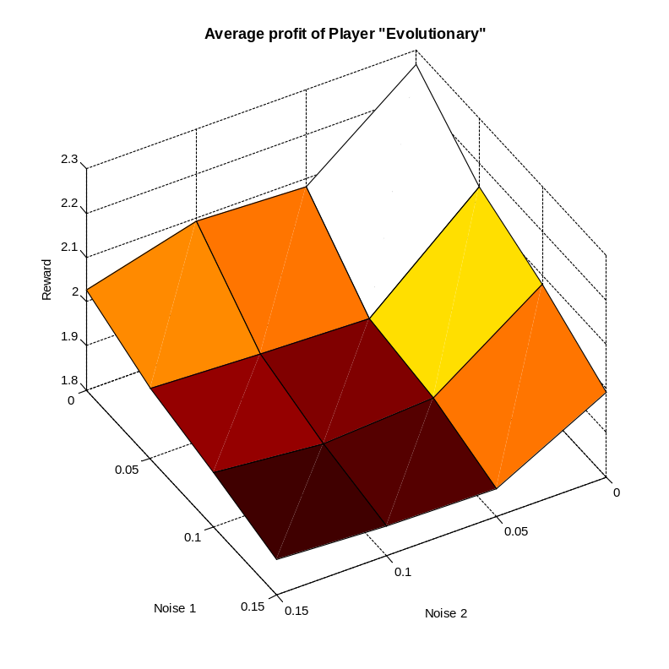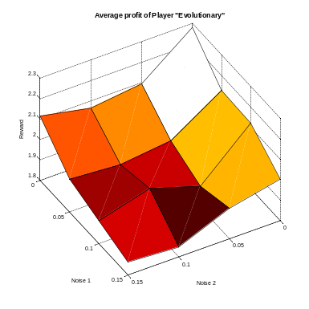
This player performs rather poorly at all noises. Less Noise is better for him, because more reliable information allows the player to adjust. Noise generally promotes bad strategies, while they are sorted out when there is little noise. The problem is that this players does add rejections and therefore triggers others rejections. The player himself has a very slow reaction time. Changing his strategy by mutations takes hundreds of turns. This is a stimescale the opponents cannot see. To the opponents this player does not look responsive. The player himself can only see the opponents reaction if it is within the segment legnth that the player tries to optimize. The interesting thing is that this player is able to exploit TF2T, he will add defections with mostly one sometimes two cooperative steps between them. It has a performance of 3.65 against TF2T at zero noise.

Cooperation of Evolutionary depending on the noise:
0.4330 0.4941 0.5151 0.4878
0.3859 0.4745 0.4860 0.4855
0.3987 0.4750 0.4919 0.4914
0.3755 0.4793 0.4733 0.4896
The decisions seem to be mostly an even mix of defections and cooperations, with a slight preference of defections.

Limited Reconciliation TFT

Performance:
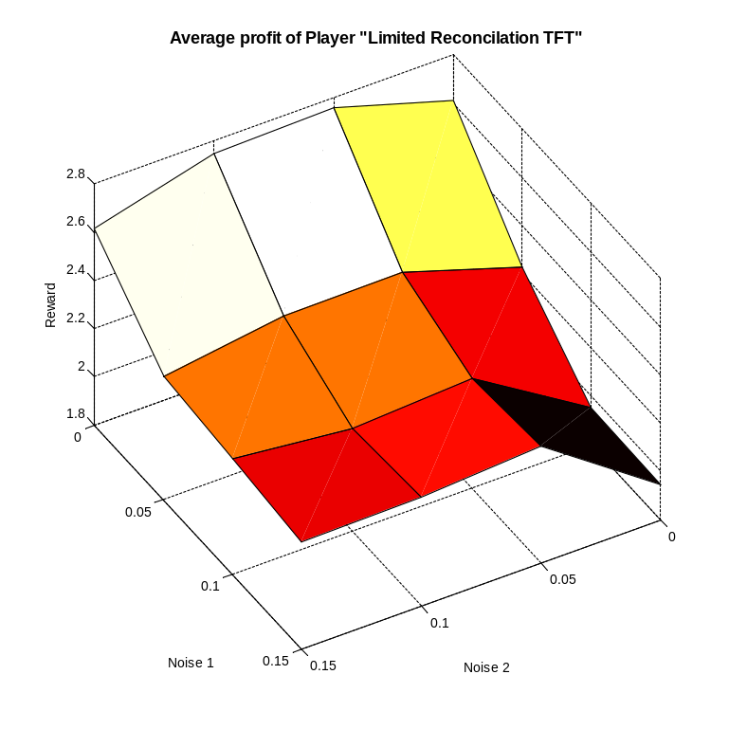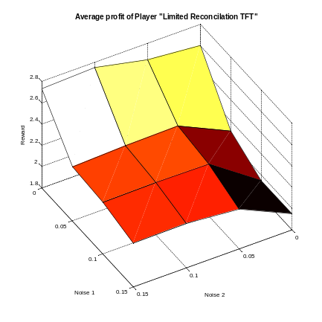
At noise1 equal to zero the performance is similar to TFT. It does not perform as well as Reconciliation TFT against Joss, therefore it might be wiser to make the time between the reconciliation attempts larger every time, instead of limiting it to 3. Compared to TFT its performance does not break down that much with noise1, this is a property it shares with Diekmann, TFAT and Reconciliation TFT. The fact that the number of reconciliation attempts is limited makes the player stronger against defecting players like Friedmann (under noise1) and "Defect".

Number of Cooperative moves as a function of the noise:
0.8064 0.8386 0.8942 0.8976
0.5084 0.6577 0.6834 0.7043
0.4254 0.6300 0.6568 0.6822
0.4208 0.5956 0.6383 0.6648

It is not as cooperative as the friendliest TFT mutants Diekmann and RTFT, but more friendly than standard TFT and TFAT.

